Los Angeles Hosts Women Writers

Just-published authors Dawn Blume Hawkes, Rossandra White and Kay Rae Chomic

July 20 – 2:00 PM • Chevalier’s Books • 126 N. Larchmont Blvd.• Los Angeles, CA 90004, CA 90266 • 323-465-1334

On July 20th at 2pm, Chevalier's Books in Larchmont Village, Los Angeles, will host an afternoon of readings and lively discussion with writers Dawn Blume Hawkes, Kay Rae Chomic, and Rossandra White, whose books were recently published by She Writes Press.

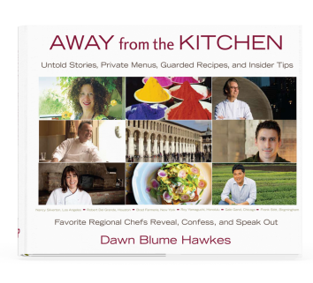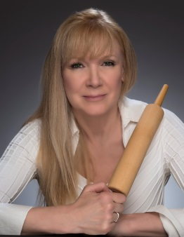
AWAY from the KITCHEN: Photo by Don Saban
Untold Stories, Private Menus,
Guarded Recipes, and Insider Tips
By Dawn Blume Hawkes

A look into the secret lives of notable chefs from across the country, capturing the highs and the lows of life inside and outside the kitchen.
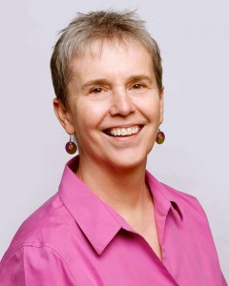
A Tight Grip Photo by Jeremy Cortez
By Kay Rae Chomic

Jane “Par” Parker discovers the transformative power of adversity, and seizes options to evolve as a person, an athlete, and a best friend in this story that offers touching insight into the midlife transition.
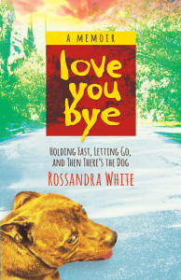
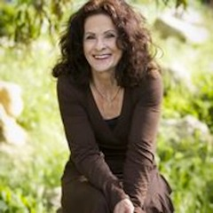
Loveyoubye: Holding Fast, Photo: Garth Milan
Letting Go, and Then There’s The Dog
By Rossandra White

A confluence of crises on two continents forces White to face her demons and make a decision: stay in a twenty-five year marriage that’s crumbling, or leave and forge a new life for herself.

